The Conference is devoted to fundamental and applied problems of membrane and sorption processes.
Topics:
- synthesis of organic and inorganic membranes
- ion exchange and sorption
- structure and properties of membranes
- ion and water transport in membranes and membrane systems
- bipolar membranes
- modification of membrane materials
- actual problems of membrane electrochemistry
- membrane catalysis, interface phenomena
- mass transfer intensification in electromembrane modules
- desalination, concentration, purification and separation of liquid mixtures by electrodialysis, hybrid membrane methods
- membranes in hydrogen energy
- membrane nanoscience and nanotechnology

Round tables:
- Membrane materials for alternative sources of energy
- Perspectives of development of hybrid membrane technologies
- Optimization and intensification of electromembrane processes
Integrated events
- Russian-French seminar on membrane science key topics
- young scientists competition in the field of membranes and membrane technology “Russian YoungMemBrain” RYM’2013
- School for young researchers including reviewing lectures of leading scientists; oral presentations and poster session of young researchers; demonstration of laboratory equipment, manuals and school-books.
LANGUAGE
Working languages are Russian and English.

CALL FOR PAPERS
DEADLINE FOR SUBMISSION: April 30, 2013
Participants are invited to submit abstracts for oral and/or poster presentations. Abstracts of general interest are submitted for the plenary session.
- Please submit abstracts according to the attached template (use A4 format sheets, border it to 2.5 cm; 1.5 line spacing, font Times New Roman, size 12). Diagrams and graphics are allowed. The size of abstract is up to 3 pages.
- Abstracts should be sent via e.mail to kononenk@chem.kubsu.ru in a Word for Windows format (version 6.0 or later). For any questions, please, contact, Mme Natalia Kononenko (kononenk@chem.kubsu.ru) or Mr Victor Nikonenko (v_nikonenko@mail.ru ).
All accepted abstracts will be included in a hardcopy Proceedings of the Conference.
LOCATION
″Avtotransportnik Rossii″ Hotel, pos. Agoi, Tuapse, Krasnodar Territory, Russia, about 150 km from the Krasnodar airport.
Fees
The registration fee is 350 €. It includes preparation and sending official invitation, proceedings, Krasnodar-hotel-Krasnodar transport by bus, coffee breaks, barbecue, welcome party and conference dinner. The fee is reduced for young researchers: 200 €.
Two bus runs will be organized: June 2, at 15h30, from the Krasnodar airport to the hotel, and June 7, at 10h00, from the hotel to the Krasnodar Airport. Organizing committee can order a taxi to meet a participant at the Krasnodar airport and transport him to the hotel, the price is about 75 €.
The hotel accommodation including three meals a day is paid to the hotel stuff. The price per person is about 50 € per day (the case of 2-person accommodation in a double room). In the case of one person/double room the coefficient is 1.5. The registration and accommodation fees are paid at arrival to the hotel. It is possible to pay the hotel via bank transfer (18% VAT will be aided).

REGISTRATION FORM
Name...............................................................
Institution..................................................... .......................................................................
Full mailing address............................................
.......................................................................
Tel (please indicate country and area code) ...................................................................
Fax.................................................................
E-mail...........................................

I would like to (choose an option, please)
- submit an oral presentation
- submit a poster
- participate in conference without submission
Names of authors, titles of abstracts
........................................................................
........................................................................
Please, complete the form and send it to the Organizing Committee before April 30, 2013 by e.mail (v_nikonenko@mail.ru).
Scientific/ORGANIZING COMMITTEE
Yaroslavtsev A.B., Corresponding Member RAS (Russia) – Chairman
Zabolotsky V.I., Academician Int. Hi. Ed. Acad., Prof. (Russia) – Co-chairman
Pourcelly G., Prof. (France) – Co-chairman

Ageev E.P., Prof. (Russia)
Berezina N.P., Prof. (Russia)
Bildyukevich A.V., Prof., (Belarus)
Dammak L., Prof. (France)
Filippov A.N., Prof. (Russia)
Gnusin N.P., Prof. (Russia)
Grafov B.M., Prof. (Russia)
Khokhlov A.R., Academician RAS (Russia)
Larchet C., Prof. (France)
Ozerin A.N., Corresponding Member RAS (Russia)
Nikonenko V.V., Prof. (Russia)
Novak L., president MEGA (Czech Republic)
Pismenskaya N.D., Prof. (Russia)
Rubinstein I., Prof. (Israel)
Shaposhnik V.A., Prof. (Russia)
Shudrenko A.A., director ITC “Kuban-Yug”
(Russia)
Sistat P., Prof. (France)
Starov V.M., Prof., Fellow of the Royal Society of Chemistry (UK)
Tskhay A.A., president OAO Membrane Technologies (Kazakhstan)
Volfkovich Yu.M. Prof. (Russia)
Volkov V.V., Prof. (Russia)

CONFERENCE SECRETARIAT:
Kononenko N.A., Prof. (Russia)

CONTACT Addresses
Tel: +7-861-2199-573
Fax: +7-861-2199-517
E-mail: kononenk@chem.kubsu.ru;
v_nikonenko@mail.ru

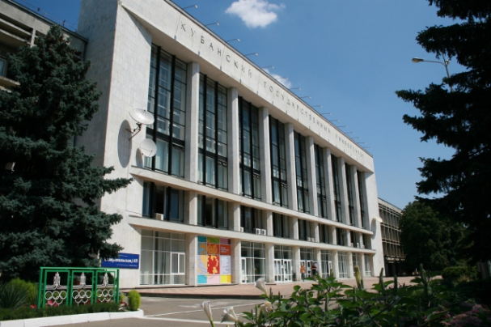
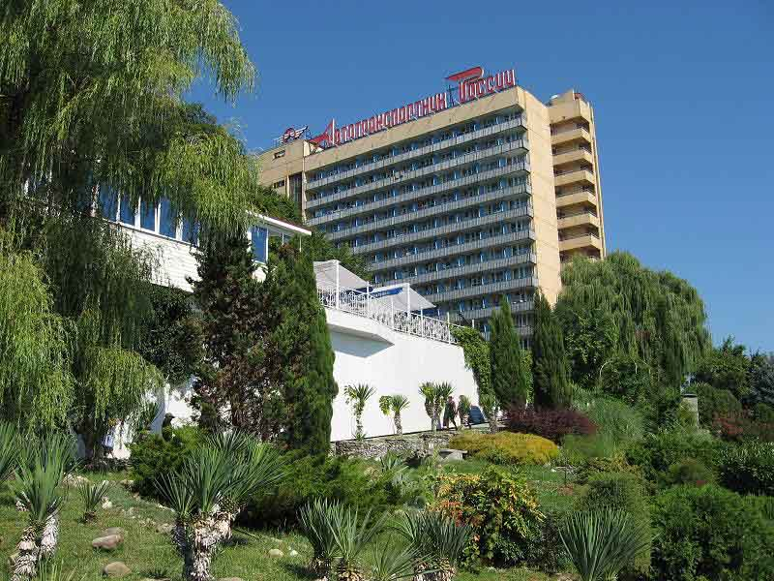
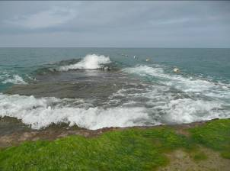
section “membranes and membrane technologies” of D.I. Mendeleev Russian Chemical Society
RUSSIAN MEMBRANE network
RUSSIAN FOUNDATION FOR BASIC RESEARCH
RAS scientific council on physical chemistry
KUBAN STATE UNIVERSITY
N.S. Kurnakov Institute of General and Inorganic Chemistry RAS
LLC "Interregional SERVICE CENTER OF SMALL AND MEDIUM ENTERPRISES YUGINFORMINVEST"
Innovation technological center “Kuban-Yug”
“MEMBRANE TECHNOLOGY” INNOVATION ENTERPRISE

INTERNATIONAL CONFERENCE
ION TRANSPORT IN organic and inorganic MEMBRANES
2 − 7 June 2013
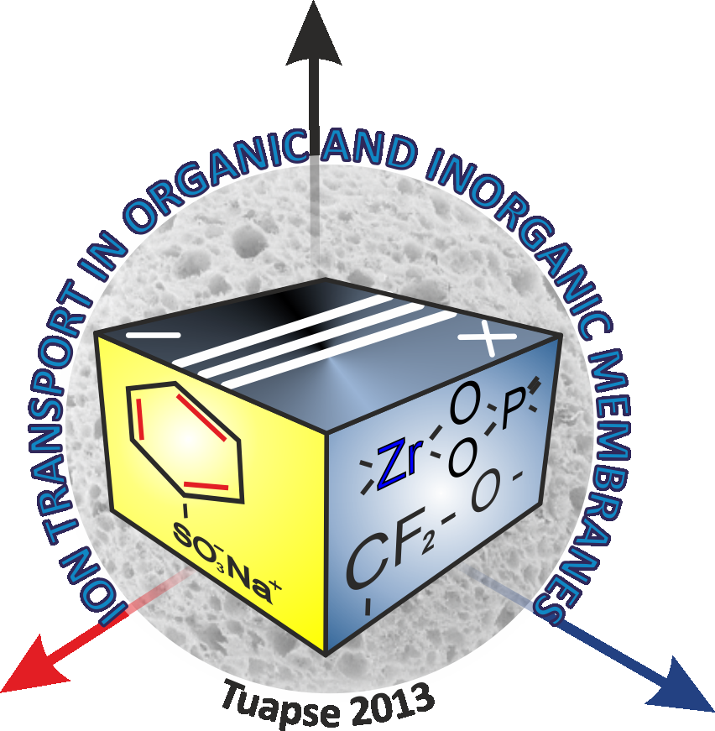

Krasnodar−Tuapse, Russia

